Student’s Worksheet 1

Speaking Part 3 – giving advice and recommendations
Look at the expressions below. They all give the same advice (go for a walk).

Match the beginning of each expression with the correct ending.

If I were you, | to go for a walk.
I reckon you | go for a walk.
How about | not go for a walk.
I’d advise you | I’d go for a walk.
Make sure you | go for a walk?
You’d better | going for a walk?
Why don’t you | should go for a walk.

Student’s Worksheet 2

Speaking Part 3 – task overview

Listen and answer the questions about Part 3 of the Linguaskill Speaking test.

- What do you see on the screen?
- Do you see all the information at the same time?
- How much time are you given to read the information on the screen?
- Do you hear the friend’s message?
- How long do you have to speak for?
- When you give your response, who are you speaking to?

Student’s Worksheet 3

Linguaskill Speaking Part 3 – sample task
Look at the text message from the sample task. Make notes on the points below.

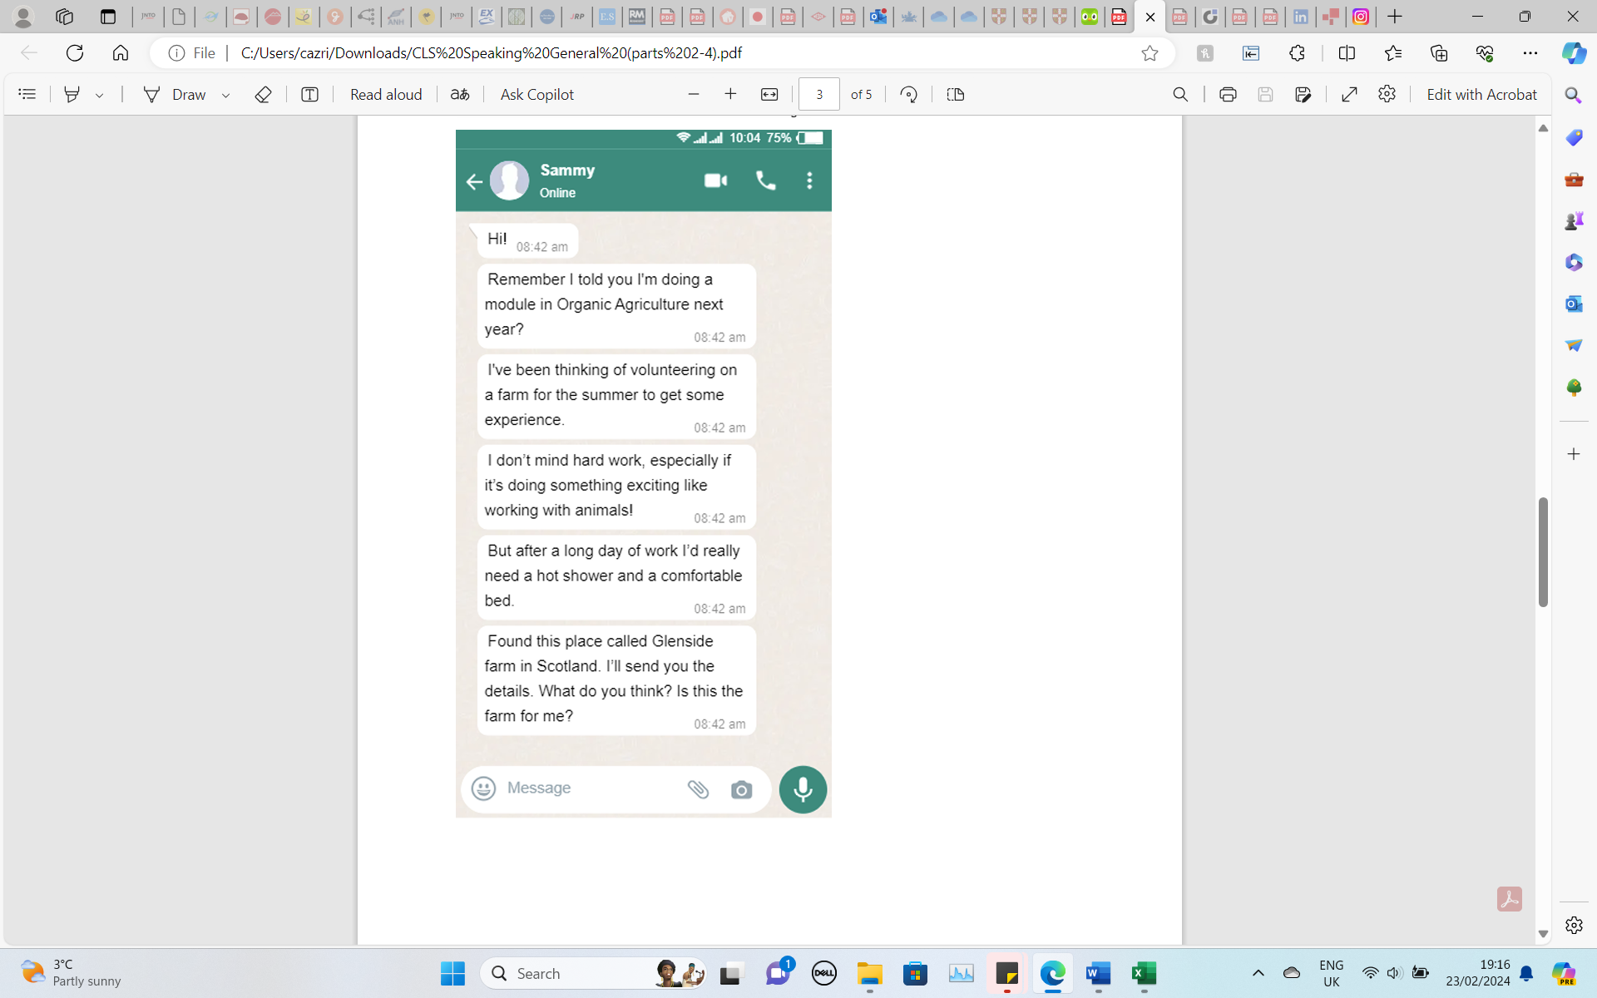

- Why is Sammy writing?
- What is important to Sammy?
- What information has Sammy found?

