Student’s Worksheet 1

Exercise 1

Match the two halves (1 – 8 and a – h) to make expressions which are used to ask for help. There may be more than one possible answer.

- Would you mind | - pass me that pen?
- Can you | - postpone the meeting until next week.
- Give me | - opening the window?
- Is there any chance you could | - me a favour and contact the suppliers?
- Are you OK | - a hand with this, will you?
- I’d appreciate it if you could | - do with some help with this report.
- Could you do | - check this?
- I could | - to finish off this report?

Exercise 2

Complete the requests for help (1 – 8).

- Oh, hi Maria, ………….. you OK to help me with this report?
- Jason, ………… you contact someone about the printer?
- Could you do me a ………….. and email the supplier about their latest order?
- Would you ………… rearranging the meeting for next week?
- I’d ………………….. it if you could find somewhere quieter for me to work.
- Clara, give me a ………… moving these files, will you?
- I could …….. with some help with these customer complaints.
- Is there any …………… you could start the meeting an hour later?

Student’s Worksheet 2

Underline the expressions below which are used to ask for help.

Oh hello. It’s Maria here from the Human Resources office. I wonder if you could send someone up to help us. There’s an old filing cabinet here that’s taking up too much room. Could someone come remove it, please? We don’t use it anymore as all our records are on computer. We’re pretty much a paperless office now! Thanks.

Student’s Worksheet 3

For this question, choose the correct answer.
Read the question first. You can listen twice.

A woman is phoning a colleague about a problem in her office. What does she want someone to do?

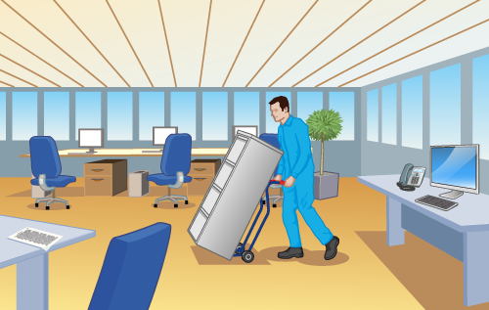 | 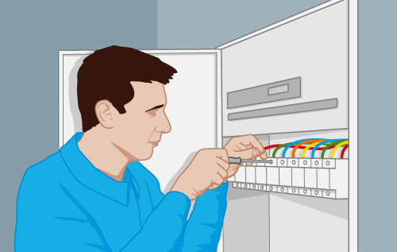 | 
A | B | C

Student’s Worksheet 4

For this question, choose the correct answer.
Read the question first. You can listen twice.

A man is speaking to a colleague at work called Tom. What does he need Tom to do?

 | 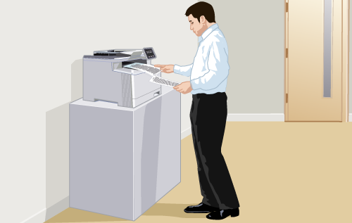 | 
A | B | C

