Listening Lesson 1

Description

This lesson prepares learners for listening to short recordings and identifying the correct option (image) in a multiple-choice question. Learners are introduced to language frequently tested in this task type and are given structured practice in a sample task. The topic of the lesson is friendships.

Teacher’s Notes

Aims of the lesson | - to raise awareness of the requirements of the task type, which features a short audio extract and three picture options  - to present and practise language related to friendships  - to develop techniques and strategies for this task type based on practice of a sample task
Time required | 40–45 minutes
Level | Suitable for B1–B2 level
Materials required | - Student’s Worksheets 1-2 (one copy for each learner)  - audio recording

Procedure

- Explain that the lesson is on the topic of friendships and will focus on language and techniques which are useful for multiple-choice short listening tasks with images, which is one of the task types in the Linguaskill Business Listening Test.

- Ask learners to write down the name of one of their friends. Depending on the size of your class, give learners numbers – i.e. 1, 2, 3, 1, 2, 3 etc. – then ask them to stand up and find all the learners with the same number. In their new groups, give the learners 5 minutes to talk together about the friend whose name they wrote down.

- Whole class feedback. Nominate some learners to report what they learned about someone’s friend. Ask the whole group questions to find out which learner has known their friend the longest. During feedback, write examples of key language of friends and relationships on the board and check understanding.

- Hand out Student’s Worksheet 1 and ask learners to complete the gapped text, which describes a friendship.

Whole class feedback to compare answers and elicit/check synonyms (e.g. fall out > have an argument; have a lot in common > have the same interests), antonyms (e.g. keep in touch vs. lose touch) and alternative expressions (e.g. close friend/good friend/best friend/acquaintance; get on/along with).

Key

Sarah and Claire were (1) best friends for over 20 years. They (2) met on their first day at school, but they didn’t really (3) get on with each other to start with. Sarah thought Claire was a bit (4) unfriendly and Claire already had a wide (5) circle of friends, so she didn’t feel the need to (6) make any new ones. Anyway, they started chatting after a lesson one day and that’s when they discovered they had a lot in (7) common – they had really similar (8) interests in music and hobbies - so they started spending more time together. Before long, they were doing everything together and they never (9) fell out or got angry with each other about anything. When Sarah got married, she moved to Australia. They promised to (10) stay friends, but it was difficult and they eventually (11) lost touch.
fell stay make best tastes lost
unfriendly met get circle common

- Ask learners where Claire and Sarah met (Key – at school) and where the learners met their own best friends. Write responses on the board and elicit other places/ways to meet people. Ask learners to look at the pictures on Student’s Worksheet 1 Exercise 2 and tell them these are also ways/places to make friends. Ask learners to chat with a partner about what these ways/places are and how easy it is make friends in this way. (Key – accept any appropriate response based on the images. The ways/places depicted for this task are: A – at school/at college/while studying; B – at a sailing club/while sailing (hobby); C – at work/while working). Check responses as a class.

- Explain that the images from the activity above come from a Linguaskill listening task. Write the question on the board: Where did the man meet his best friend? Tell learners that you are going to play the recording so that they can answer the question. Ask them why you asked them to look at the pictures first. (Key – to predict vocabulary/anticipate what they are going to hear) and explain that this is a useful technique when answering questions like this as it makes their listening more focused. Play the recording.

- Whole class feedback on the key (B). Play the recording again if necessary. Give learners Student’s Worksheet 2 Exercise 1 with the transcript of the recording and ask them to underline all references to the three places/activities shown in the three images. Point out that references to all three images occur more than once in the recording. Ask them to discuss with a partner why the other two options were incorrect, then check as a class.

Key

M: I have a lot of friends. I keep in touch with people I knew in school and college, and get together with them whenever I can. But I didn’t meet my best friend, Andy, until I’d left college and started my first job. I worked for a construction firm and at weekends I went sailing in order to get out into the fresh air away from the dust and dirt of my workplace. Andy joined the sailing club at the same time as me, and we soon became best friends. He was a teacher, so we had completely different jobs, but that didn’t stop us getting along very well.

- Option A – in school and college/until I’d left college/teacher - incorrect because of the negative and past references in But I didn’t meet my best friend … until I’d left college.

- Option B – went sailing/sailing club - correct because Andy joined the sailing club at the same time as me, and we soon became best friends.

- Option C – my first job/worked for a construction firm/my work place/jobs - incorrect because we had completely different jobs.

- Ask learners to look at Student’s Worksheet 2 Exercise 2 and complete the True/False table with advice on completing these Listening tasks. Tell them to think about the task they have just done to help them. Feedback as a whole class.

Key

 | True? | False? | Why?
Listen to the recording before you look at the pictures. |  | X | Look at the pictures first so you know what you are listening for and can start thinking about vocabulary you will hear.
Only the correct picture will be referred to in the recording. |  | X | All three pictures will be mentioned in the recording, sometimes more than once.
It’s important to listen carefully to the verb tenses used. |  |  | A different tense may change a correct answer into an incorrect one (e.g. Option A in the sample task I didn’t meet … until I’d left). Check the tense in the question as well.
The correct picture will be mentioned more than the other two pictures. |  | X | It may be mentioned the same amount of times or even less than the other pictures.
Make sure you keep listening until the end of the recording. |  |  | An answer may seem right (e.g. I didn’t meet my best friend, Andy, until I’d left college and started my first job seems to say he met his best friend at work, but this is then ruled out when he mentions the sailing club he joined to get away from work.
You hear the recording twice. If you have decided on an answer, you should move onto the next question. |  | X | Use the second recording as a chance to check you have the right answer. It’s easy to make a quick match when you hear a similar word, but the details of the context may make this wrong.
The answer is always in the middle of the recording. |  | X | The answer can be at the beginning, middle or end of the recording, so you need to be ready to listen and keep listening right until the end.

- To close the lesson, you could ask learners to talk together about friendships in general, e.g. What makes a good friendship?/Is it better to have one really good friend or lots of friends?/Do friends always have to have the same interests? etc.

Audio script

M: I have a lot of friends. I keep in touch with people I knew in school and college, and get together with them whenever I can. But I didn’t meet my best friend, Andy, until I’d left college and started my first job. I worked for a construction firm and at weekends I went sailing in order to get out into the fresh air away from the dust and dirt of my workplace. Andy joined the sailing club at the same time as me, and we soon became best friends. He was a teacher, so we had completely different jobs, but that didn’t stop us getting along very well.

Student’s Worksheet 1

Exercise 1

Complete the brief story of a friendship below by writing one word in each gap.

Sarah and Claire were (1) _________ friends for over 20 years. They (2) _________on their first day at school, but they didn’t really (3) _________ on with each other to start with. Sarah thought Claire was a bit (4) _________ and Claire already had a wide
(5) _________ of friends, so she didn’t feel the need to (6) _________ any new ones. Anyway, they started chatting after a lesson one day and that’s when they discovered they had a lot in (7) _________ – they had really similar (8) _________ in music and hobbies – so they started spending more time together. Before long, they were doing everything together and they never (9) _______ out or got angry with each other about anything. When Sarah got married, she moved away to Australia. They promised to
(10) _______ friends, but it was difficult and they eventually (11) _________ touch.
fell stay make best tastes lost
unfriendly met get circle common

Exercise 2

What places or ways of making friends are pictured below?

How easy is it to make friends in this way?

 | 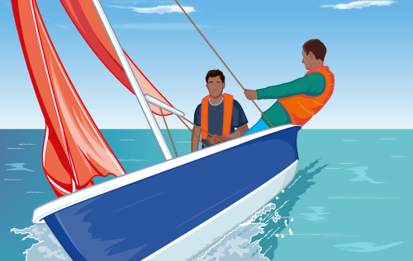 | 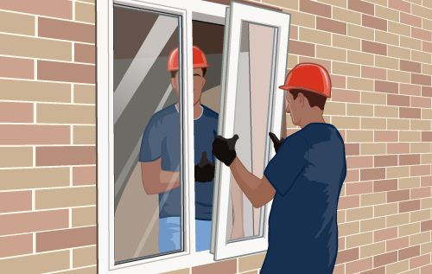
A | B | C

Student’s Worksheet 2

Exercise 1

Look at the transcript of the recording you have just listened to. Underline all the references to the three images in the question for this task.

I have a lot of friends. I keep in touch with people I knew in school and college, and get together with them whenever I can. But I didn’t meet my best friend, Andy, until I’d left college and started my first job. I worked for a construction firm and at weekends I went sailing in order to get out into the fresh air away from the dust and dirt of my workplace. Andy joined the sailing club at the same time as me, and we soon became best friends. He was a teacher, so we had completely different jobs, but that didn’t stop us getting along very well.

Exercise 2

Think about the listening task you have just completed and look at the advice in the table below. Is the advice good or bad? Can you give reasons for your choice?

 | True? | False? | Why?
Listen to the recording before you look at the pictures.
Only the correct picture will be referred to in the recording.
It’s important to listen carefully to the verb tenses used.
The correct picture will be mentioned more than the other two pictures.
Make sure you keep listening until the end of the recording.
You hear the recording twice. If you have decided on an answer, you should move onto the next question.
The answer is always in the middle of the recording.

