Student’s Worksheet 1

Exercise 1

Complete the brief story of a friendship below by writing one word in each gap.

Sarah and Claire were (1) _________ friends for over 20 years. They (2) _________ on their first day at school, but they didn’t really (3) _________ on with each other to start with. Sarah thought Claire was a bit (4) _________ and Claire already had a wide
(5) _________of friends, so she didn’t feel the need to (6) _________ any new ones. Anyway, they started chatting after a lesson one day and that’s when they discovered they had a lot in (7) _________ – they had really similar (8) _________ in music and hobbies – so they started spending more time together. Before long, they were doing everything together and they never (9) _______ out or got angry with each other about anything. When Sarah got married, she moved away to Australia. They promised to
(10) _______ friends, but it was difficult and they eventually (11) _________ touch.
fell stay make best tastes lost
unfriendly met get circle common

Exercice 2

What places or ways of making friends are pictured below?
How easy is it to make friends in this way?

 |  | 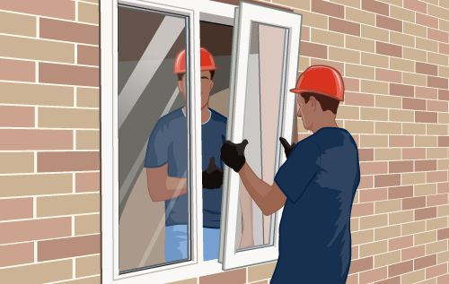
A | B | C

Student’s Worksheet 2

Exercise 1

Look at the transcript of the recording you have just listened to. Underline all the references to the three images in the question for this task.

I have a lot of friends. I keep in touch with people I knew in school and college, and get together with them whenever I can. But I didn’t meet my best friend, Andy, until I’d left college and started my first job. I worked for a construction firm and at weekends I went sailing in order to get out into the fresh air away from the dust and dirt of my workplace. Andy joined the sailing club at the same time as me, and we soon became best friends. He was a teacher, so we had completely different jobs, but that didn’t stop us getting along very well.

Exercise 2

Think about the listening task you have just completed and look at the advice in the table below. Is the advice good or bad? Can you give reasons for your choice?

 | True? | False? | Why?
Listen to the recording before you look at the pictures.
Only the correct picture will be referred to in the recording.
It’s important to listen carefully to the verb tenses used.
The correct picture will be mentioned more than the other two pictures.
Make sure you keep listening until the end of the recording.
You hear the recording twice. If you have decided on an answer, you should move onto the next question.
The answer is always in the middle of the recording.

