Linguaskill Lesson Plans

Speaking Lesson 4

Description
The topic of this lesson is volunteering work. Practice of language related to giving advice and recommendations on the topic of volunteering work is used to give guidance on completing the second stage of a Part 3 task in the Linguaskill Speaking Test.
Teacher’s Notes
Aims of the lesson | - to present and practise vocabulary for giving advice and recommendations  - to raise awareness of the requirements of the Part 3 Speaking tasks  - to develop techniques and strategies for this task type based on practice of a sample task.
Time required | 50-60 minutes
Level | Suitable for B2-C2
Materials required | - Student’s Worksheet 1: Speaking Part 3 – giving advice and recommendations  - Student’s Worksheet 2: Speaking Part 3 – task overview  - Student’s Worksheet 3: Linguaskill Speaking Part 3 – sample task (volunteering on a farm)

Procedure
- Start the lesson by drawing a stick person on the board, with question marks around the head. Ask learners a question: When you need to made a decision, what do you do? Learners discuss in small groups, before sharing their ideas with the whole class. In feedback, learners may mention asking friends or family for advice. If they don’t, elicit this idea. Ask learners to discuss some questions with a partner: Is it a good idea to get advice from friends and family? How do you feel about giving advice? How can you make sure you give good advice?
- Tell learners that giving advice and recommendations is one focus of Part 3 in the Linguaskill Speaking test. Elicit one or two example expressions for giving advice/recommendations, then give learners Student’s Worksheet 1. Learners work on their own to match the beginning and ending of the different expressions, then check with a partner. In feedback, draw learners’ attention to the verb forms which follow the expression, and elicit some alternative beginnings. For example, instead of I’d advise you they could say My advice would be or It might be a good idea.
- Tell learners that giving advice/recommendations is an important element of Part 3 in the Linguaskill Speaking test. Give learners a copy of Student’s Worksheet 2 and ask them to look at the questions about the task. Tell them to listen to your description of the task requirements and answer the questions. You can use the description below or make your own version.

In part 3 of the Linguaskill Speaking test, you will read a text message from a friend about a decision they have to make with details of the friend’s requirements. You have 20 seconds to read the message. In the message, the friend says they have found a possible solution to their situation. You then see this information. This will be visual or graphic information, including data, images and icons. You have 60 seconds to look at the text message and the information about the possible solution. You can take notes while you are reading. You need to interpret your friend’s situation and the information and decide what advice or recommendations to give. You have 90 seconds to speak. You should imagine you are leaving a voice message for your friend.
Ask learners to check with a partner, then check as a whole class. In feedback, use the notes in the key to check that learners understand what is required. Explain that the text message will outline the friend’s situation and their requirements. There will not be a direct match between the requirements and the information, i.e. no direct word spots, and not all the information given will be relevant. Consequently, it will be necessary to evaluate the information, identify which parts are relevant and decide what advice to give.
- Tell learners they will now look at a sample Part 3 Speaking task. Remind them of the earlier discussion about how to give a friend good advice and discuss that one factor is understanding what the friend needs or wants. Give learners a copy of Student’s Worksheet 3 (folded in half). Learners look at the text message at the top of the worksheet and make notes on the information it gives, i.e. situation/reason for writing, criteria, information found. Check answers as a whole group. Note the language in the text message, i.e. I don’t mind vs. I’d really need. Differences like these may affect the advice to give.
- Now ask learners to unfold Student’s Worksheet 3 and look at the information about Glenside farm. Learners work on their own to highlight details which are relevant to Sammy’s situation, then check with a partner. When learners start checking with a partner, ask them to consider which details make Glenside farm suitable or less suitable for Sammy, and whether there is any other information that it would be good to mention in the response to Sammy. They should also identify information that is not relevant. To avoid overloading learners, you could call out one question, allow learners to discuss, then call out the next one. Check answers as a whole group.
- Now give learners the opportunity to practise the task. If possible, move learners so there is space between them to avoid disturbing each other. Tell them you will read the instruction (You will now have 90 seconds to recommend what your friend should do. Please speak for all the time you have.), then they can give their response, using low voices. Monitor while learners are speaking to make notes for feedback and delayed error correction.
- Ask learners to reflect on their performance and give them the opportunity to try again.
- Finish the lesson by asking learners to discuss whether they would enjoy volunteering at Glenside farm.

Student’s Worksheet 1
Speaking Part 3 – giving advice and recommendations
Look at the expressions below. They all give the same advice (go for a walk).
Match the beginning of each expression with the correct ending.

If I were you, | to go for a walk.
I reckon you | go for a walk.
How about | not go for a walk.
I’d advise you | I’d go for a walk.
Make sure you | go for a walk?
You’d better | going for a walk?
Why don’t you | should go for a walk.

KEY
If I were you, | I’d go for a walk.
I reckon you | should go for a walk.
How about | going for a walk?
I’d advise you | to go for a walk.
Make sure you | go for a walk.
You’d better | not go for a walk.
Why don’t you | go for a walk?

Student’s Worksheet 2

Speaking Part 3 – task overview
Listen and answer the questions about Part 3 of the Linguaskill Speaking test.

- What do you see on the screen?
- Do you see all the information at the same time?
- How much time are you given to read the information on the screen?
- Do you hear the friend’s message?
- How long do you have to speak for?
- When you give your response, who are you speaking to?
KEY
- What do you see on the screen? a text message from a friend and visual/graphic information
- Do you see all the information at the same time? no – first you see the text message (20 seconds), then you see the information. You may need to scroll to see both parts
- How much time are you given to read the information on the screen? 20 seconds to read the text message, then one minute to read the text message and the information
- Do you hear the friend’s message? no, you only read it
- How long do you have to speak for? 90 seconds. You should try to speak for the full time.
- When you give your response, who are you speaking to? imagine you are speaking to the friend, i.e. leaving a voice message

Student’s Worksheet 3

Linguaskill Speaking Part 3 – sample task
Look at the text message from the sample task. Make notes on the points below.
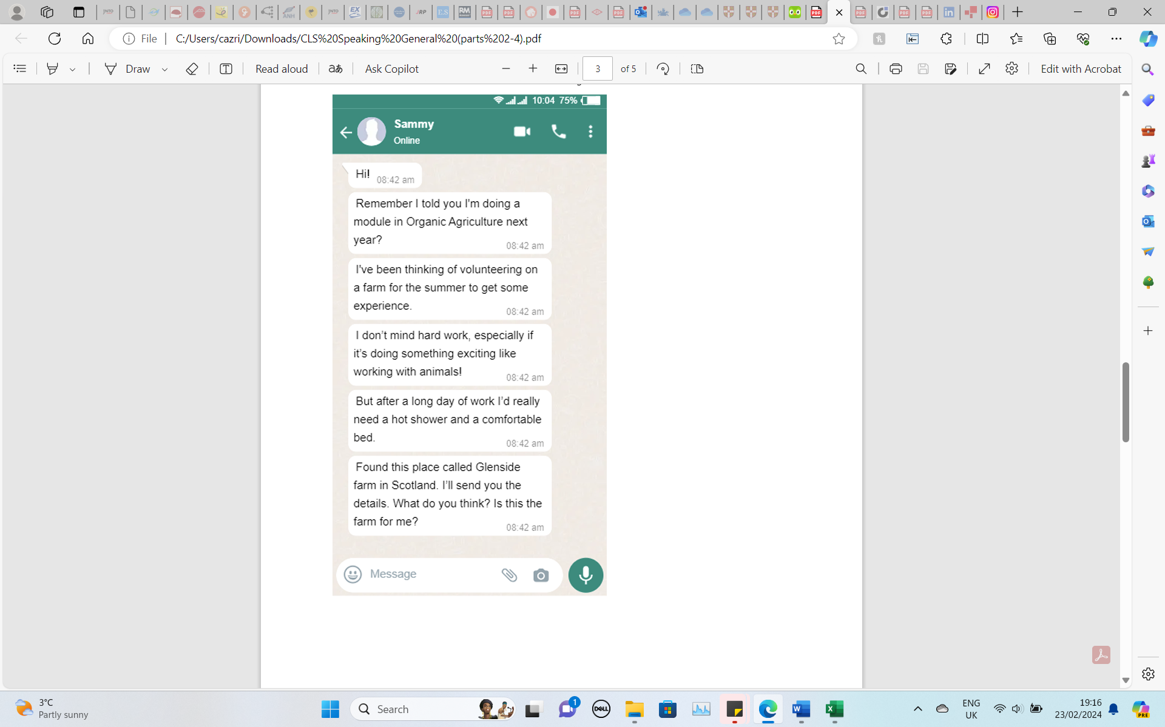
- Why is Sammy writing?
- What is important to Sammy?
- What information has Sammy found?

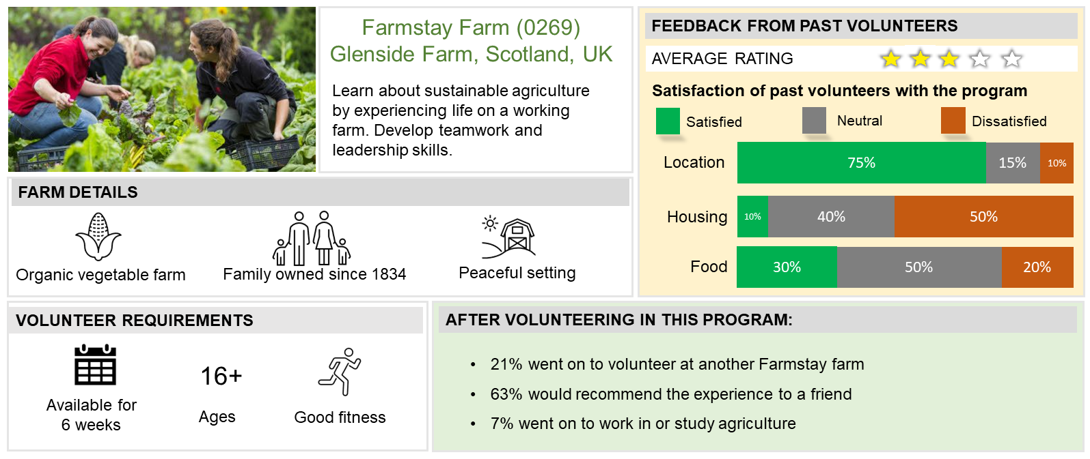

KEY
- Why is Sammy writing? Sammy wants to volunteer to get experience for his studies on Organic Agriculture.
- What is important to Sammy? Sammy can volunteer for the summer. Hard work is ok. Sammy would like to work with animals. Sammy would like comfortable accommodation with good facilities.
- What information has Sammy found? Glenside farm in Scotland.

Information to highlight: Organic vegetable farm/Available for 6 weeks/Good fitness/ /Housing satisfaction rating/Recommendation rating

Suitable | Less suitable | Other relevant information
- Farm type (organic)  - Work period (6 weeks, i.e. summer)  - Feedback (63% would recommend the experience) | - Accommodation and facilities (only 10% satisfied with housing, 50% dissatisfied)  - Farm type (vegetable farm, no mention of animals) | - ‘Develop teamwork’ - could help with studies  - Volunteer requirements: ‘good fitness’ – could be relevant to Sammy’s comment I don’t mind hard work  - General comments about the environment and atmosphere (Family owned, peaceful setting, good location – likely to be a good place to spend time, despite the possible concerns)

