Linguaskill Business Lesson Plans

Speaking Lesson 4

Description
The topic of this lesson is project management. Practice of vocabulary related to project management and training courses is used to give guidance on completing the second stage of a Part 3 task in the Linguaskill Business Speaking Test.
Teacher’s Notes
Aims of the lesson | - to present and practise language for discussing project management and work training courses  - to raise awareness of the requirements of the Part 3 Speaking tasks  - to develop techniques and strategies for this task type based on practice of a sample task.
Time required | 50-60 minutes
Level | Suitable for B2-C2
Materials required | - Student’s Worksheet 1: Speaking Part 3 – giving advice and recommendations  - Student’s Worksheet 2: Linguaskill Business Speaking Part 3 – sample task (Project manager training course)  - Student’s Worksheet 3: Speaking Part 3 – confirming and contradicting

Procedure
- Write Project Management on the board. Ask learners to tell you what this involves and what issues it deals with. If not suggested, elicit the importance of time and budget control for effective project management. Ask learners what companies can do if they want to improve their employees’ project management skills, to elicit the idea of training. Write on the board in house, outsourced, online, face-to-face and ask learners to work in small groups discussing the advantages and disadvantages of these types of training. As a whole group, feed back on some of the ideas discussed and check understanding of key vocabulary.
- Tell learners that project management is the focus of a Part 3 Linguaskill Business Speaking task. Give learners a copy of Student’s Worksheet 1, folded so that they only see A or B. Learners work in pairs of A and B to ask and answer questions so they complete the full instructions for the task. In feedback, explain that during the test, there will also be simple instructions for each stage, i.e. You will now have 20 seconds to read the text message; You will now have 1 minute to look through the information. You can take notes while you look through the information; You will now have 90 seconds to recommend what your friend should do. Please speak for all the time you have. Ask learners if they have any questions about what this part of the Speaking test involves.
- Tell learners they will now look at a sample Part 3 Speaking task. Refer to task instructions from the previous stage of the lesson and ask learners: What is the first thing you need to do? Agree that they need to look at the text message and use the 20 seconds to identify what the colleague needs or wants. Give learners a copy of Student’s Worksheet 2 (folded in half). Learners look at the text message at the top of the worksheet and make notes on the information it gives, i.e. situation/reason for writing, criteria, information found. Check answers as a whole group. Note how Annie says: one of our key priorities and the VP has put me in charge. These comments highlight the importance of making the right decision, which may be something learners can mention in their response.
- Now ask learners to unfold Student’s Worksheet 2 and look at the information about the training course. Learners work on their own to highlight details which are relevant to Annie’s situation, then check with a partner. When learners start checking with a partner, ask them to consider which details make this training course suitable or less suitable for Annie’s company, and whether there is any other information that it would be helpful to mention in the response to Annie. Also ask them to decide what information is less relevant to Annie’s situation. Check answers as a whole group.
- Tell learners that they have evaluated the relevance of the information to the situation expressed in the text message. The next step is to make their recommendation to Annie. To do this effectively, they need to use a range of cohesive devices to link ideas from across the written input, i.e. the text message and the information. They may need to use linkers to contradict (say why the course is not suitable) or to confirm (say which elements of the course make it suitable). Give learners a copy of Student’s Worksheet 3 and look at the two examples together. Make sure learners realise they may need to use one or two sentences to connect the ideas. Ask learners to work on their own, then check with a partner. Monitor while learners are working to identify possible variations on the key and points for delayed error correction.
- Now give learners the opportunity to practise the task. If possible, move learners so there is space between them to avoid disturbing each other. Ask learners to look again at Student’s Worksheet 2, unfolded, so they can see the whole task. Tell them you will read the instruction (You will now have 90 seconds to recommend what your colleague should do. Please speak for all the time you have.), then they can give their response, using low voices. Monitor while learners are speaking to make notes for feedback and delayed error correction.
- Ask learners to reflect on their performance and give them the opportunity to try again.
- Finish the lesson by asking learners to discuss effective training courses they have attended. What were the courses for? What made them effective?

Student’s Worksheet 1

Speaking Part 3 – giving advice and recommendations
Look at the description of the Speaking Part 3 task. Some of the information is missing.
Ask your partner questions to find the missing information.
A
You have received a _________ and some information from a friend, who needs your help to decide about something. You should respond to your friend's request by ________ where you evaluate the information and decide whether it fits your friend’s requirements.
First you will have 20 seconds to read the text message. Then you will have ________ to look at all the information. The information will remain on the screen. You will then have 90 seconds to give your recommendation. You can ________ while you read the text message.
B
You have received a text message and some information from a friend, who needs your help to ________. You should respond to your friend's request by leaving a voice message where you evaluate the information and ________.
First you will have ________ to read the text message. Then you will have 1 minute to look at all the information. The information will remain on the screen. You will then have ________ to give your recommendation. You can take notes while you read the text message.

KEY
You have received a text message and some information from a friend, who needs your help to decide about something. You should respond to your friend's request by leaving a voice message where you evaluate the information and decide whether it fits your friend’s requirements.
First you will have 20 seconds to read the text message. Then you will have 1 minute to look at all the information. The information will remain on the screen. You will then have 90 seconds to give your recommendation. You can take notes while you read the text message.

Student’s Worksheet 2

Linguaskill Business Speaking Part 3 – sample task
Look at the text message from the sample task. Make notes on the points below.
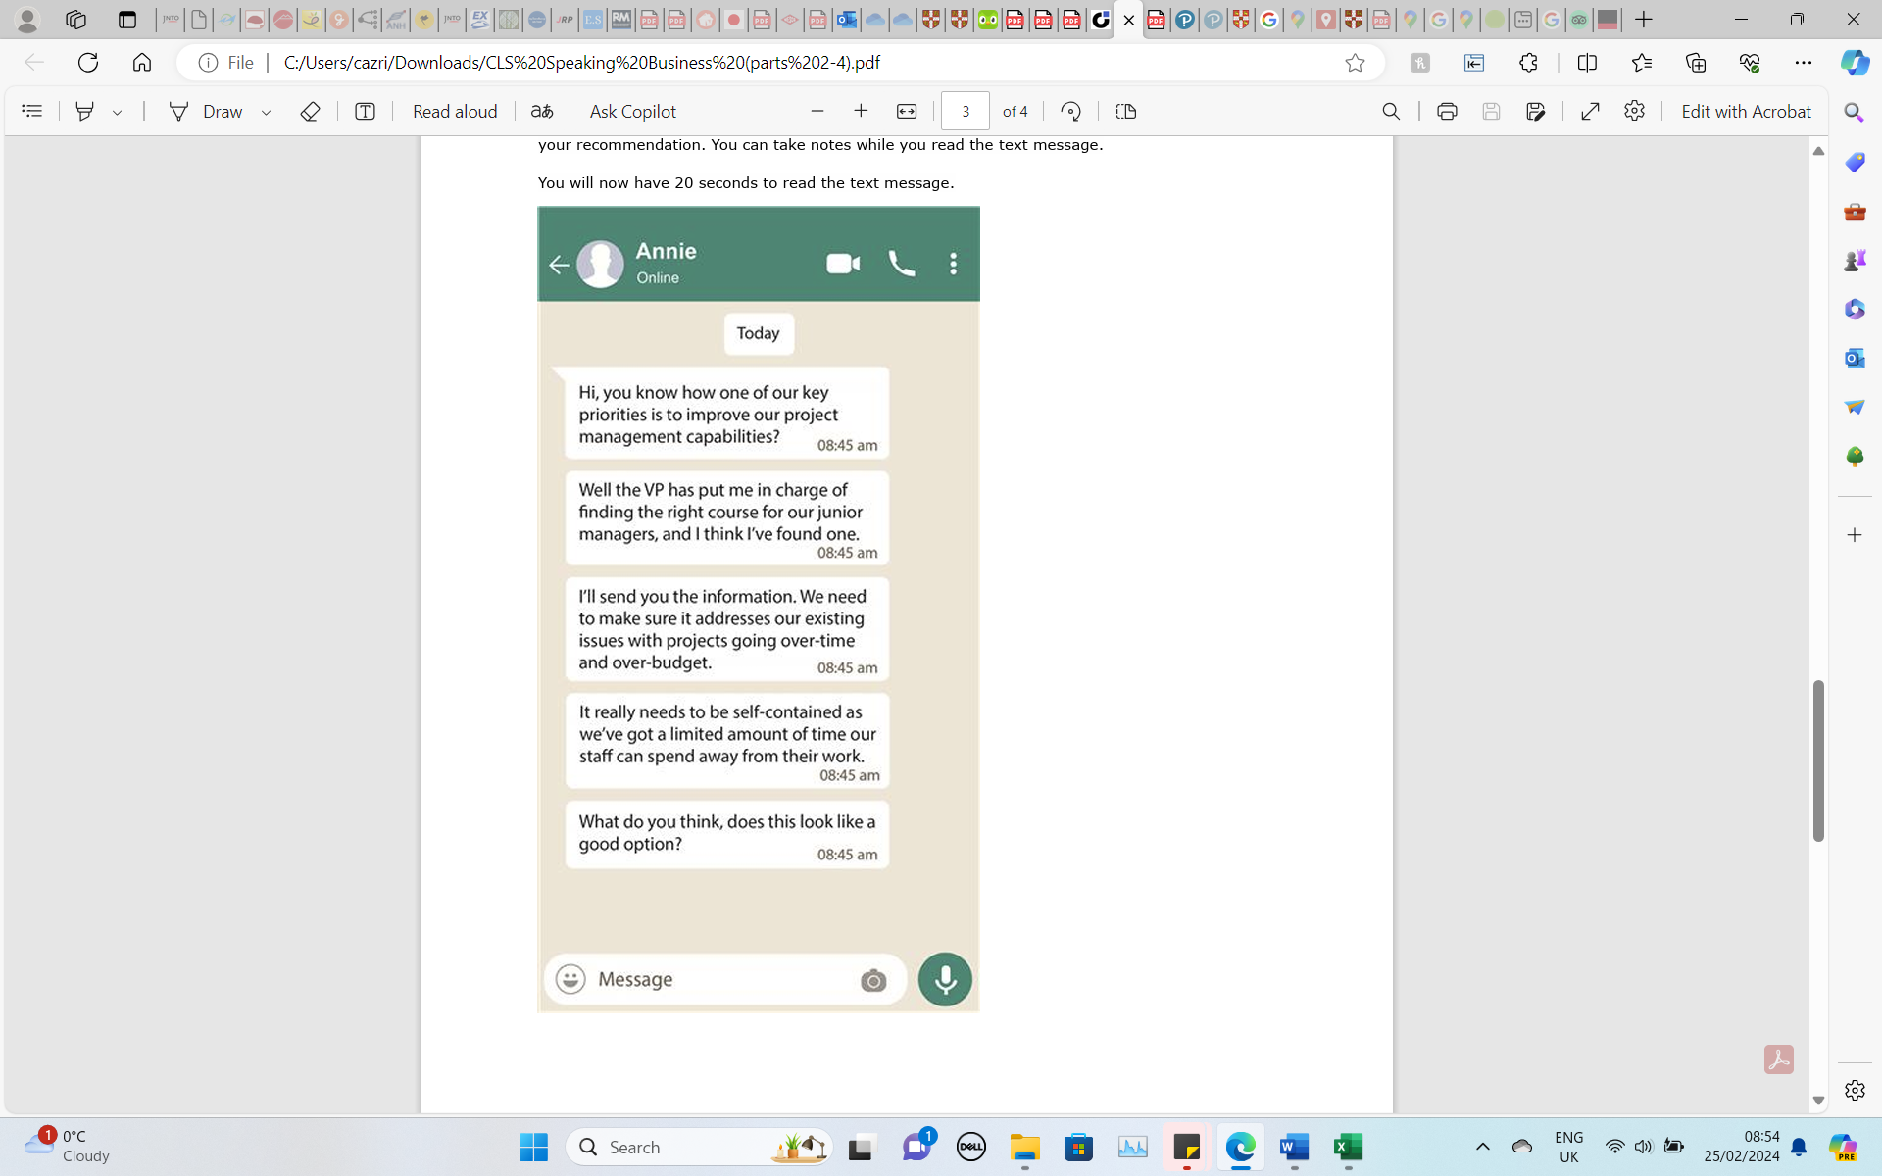
- Why is Annie writing?
- What is important to Annie?
- What information has Annie found?

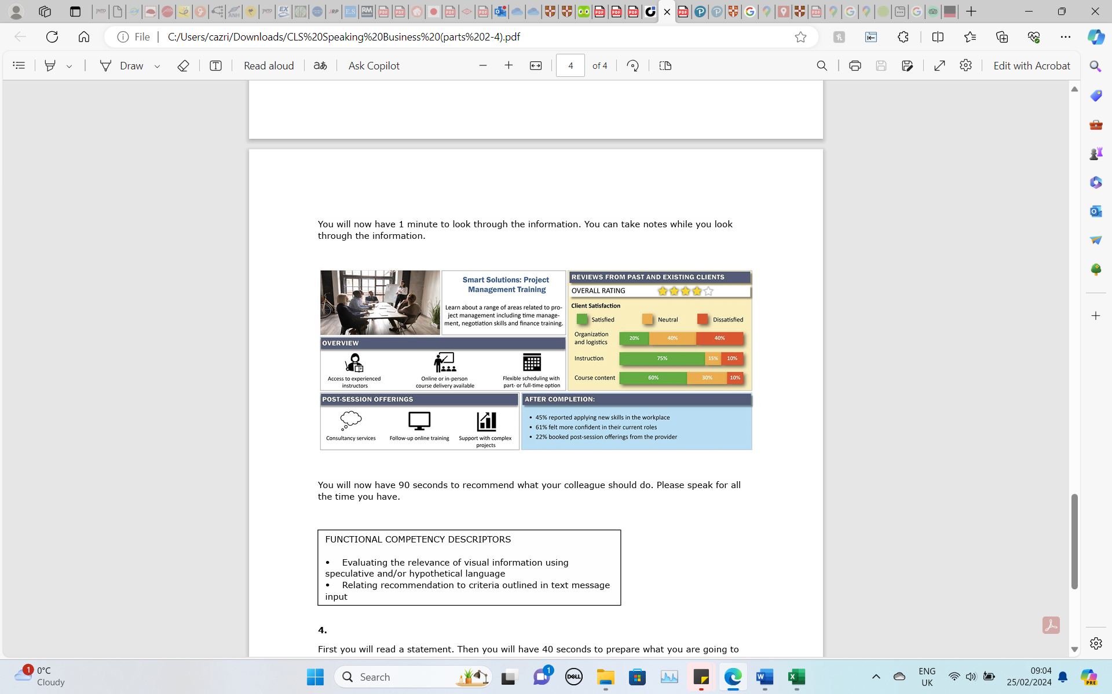

KEY
- Why is Annie writing? Annie has been put in charge of finding a course on project management for junior managers.
- What is important to Annie? The course needs to address issues with time and budget management. The course needs to be self-contained. There is limited time available for the course.
- What information has Annie found? A possible course to meet the company’s needs.

Information to highlight: range of areas related to project management including time management and finance training/online or in-person/flexible scheduling and part- or full-time/satisfaction ratings

Suitable | Less suitable | Other relevant information
- Course focus (time management and finance training specifically mentioned)  - Scheduling (flexible scheduling)  - Course delivery (online or in-person)  - Satisfaction rating (75% satisfied with the instruction, 60% satisfied with the content) | - Satisfaction rating (only 20% satisfied with the organization and logistics – could this impact on the time needed?)  - No specific reference to the target market – will it be suitable for junior managers, or is it too general? | - Follow-up online training (is this essential to get all the necessary information?)

Student’s Worksheet 3

Linguaskill Business Speaking Part 3 – confirming and contradicting
Use the words below to connect the two ideas. Think carefully about the structure of the sentences. You may need to use one or two sentences.
One example in each set has been done for you.

Confirming
the time commitment is suitable / flexible scheduling
THANKS TO: Thanks to the flexible scheduling, the time commitment is suitable.
OWING TO:
BECAUSE OF:
SINCE:
GIVEN:

Contradicting
the instruction is good / the organization is poor

WHEREAS: The instruction is good, whereas the organization is poor.
ALTHOUGH:
HOWEVER:
DESPITE:
YET:

KEY
Confirming

The time commitment is suitable owing to the flexible scheduling.
Because of the flexible scheduling, the time commitment is suitable.
Since there is flexible scheduling, the time commitment is suitable.
Given the flexible scheduling, the time commitment is suitable.

Contradicting
Although the instruction is good, the organization is poor.
The organization is poor. However, the instruction is good.
Despite the instruction being good, the organization is poor.
The instruction is good, yet the organization is poor.

