Student’s Worksheet 1

Speaking Part 3 – giving advice and recommendations
Look at the description of the Speaking Part 3 task. Some of the information is missing.
Ask your partner questions to find the missing information.

A
You have received a _________ and some information from a friend, who needs your help to decide about something. You should respond to your friend's request by ________ where you evaluate the information and decide whether it fits your friend’s requirements.
First you will have 20 seconds to read the text message. Then you will have ________ to look at all the information. The information will remain on the screen. You will then have 90 seconds to give your recommendation. You can ________ while you read the text message.
B
You have received a text message and some information from a friend, who needs your help to ________. You should respond to your friend's request by leaving a voice message where you evaluate the information and ________.
First you will have ________ to read the text message. Then you will have 1 minute to look at all the information. The information will remain on the screen. You will then have ________ to give your recommendation. You can take notes while you read the text message.

Student’s Worksheet 2

Linguaskill Business Speaking Part 3 – sample task
Look at the text message from the sample task. Make notes on the points below.

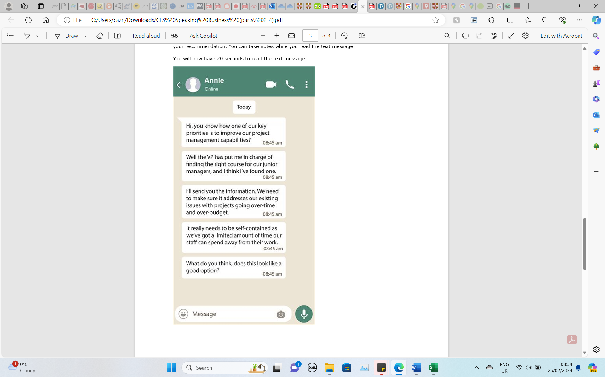
- Why is Annie writing?
- What is important to Annie?
- What information has Annie found?

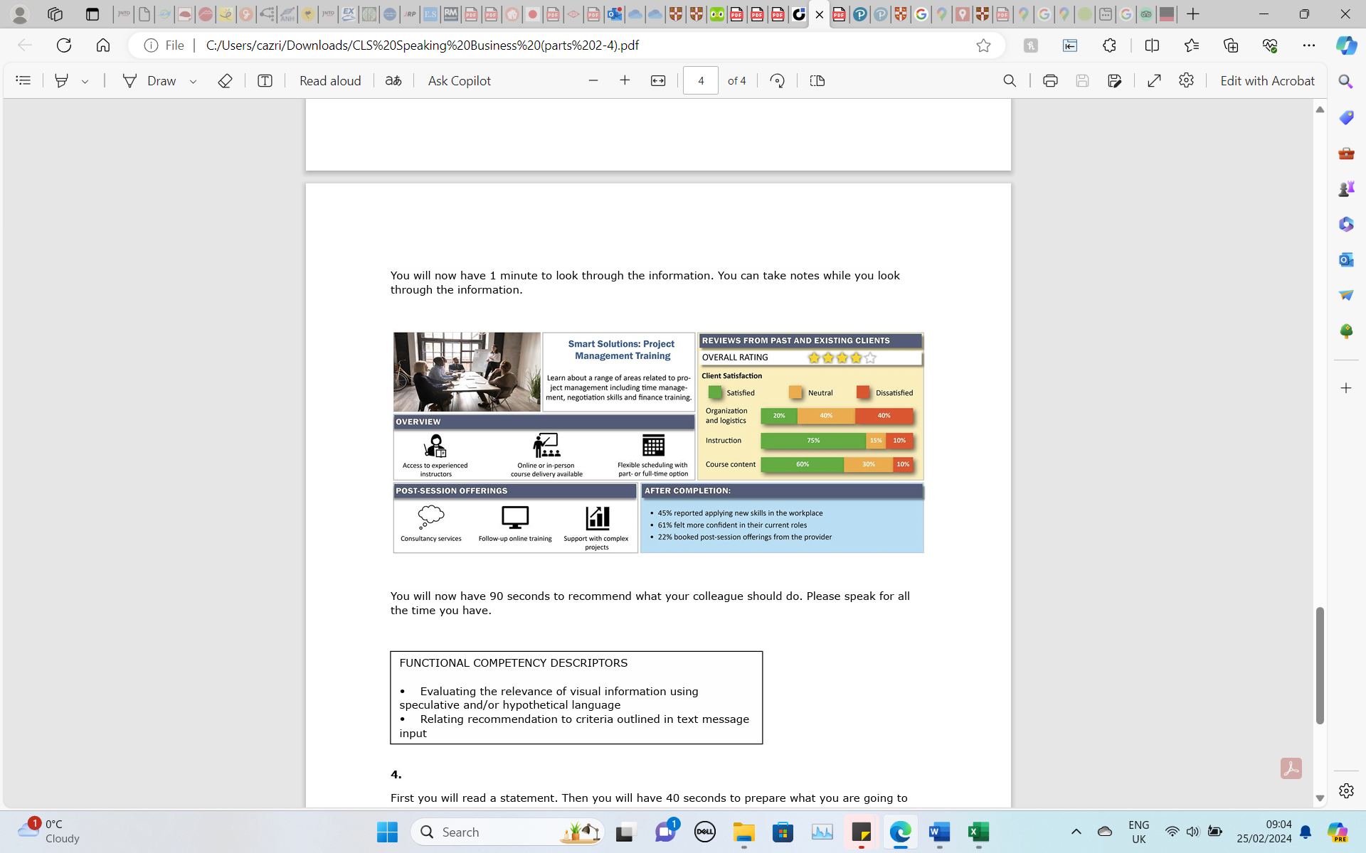

Student’s Worksheet 3

Linguaskill Business Speaking Part 3 – confirming and contradicting
Use the words below to connect the two ideas. Think carefully about the structure of the sentences. You may need to use one or two sentences.

One example in each set has been done for you.

Confirming
the time commitment is suitable / flexible scheduling
THANKS TO: Thanks to the flexible scheduling, the time commitment is suitable.
OWING TO:
BECAUSE OF:
SINCE:
GIVEN:

Contradicting
the instruction is good / the organization is poor

WHEREAS: The instruction is good, whereas the organization is poor.
ALTHOUGH:
HOWEVER:
DESPITE:
YET:

